27/08/2022

1.ADDITION OF TWO NUMBERS

#include<iostream>

using namespace std;

int main()

{

int x,y;

cout<<"enter the x and y value";

cin>>x>>y;

cout<<"sum of two numbers"<<x+y;

}

OUTPUT

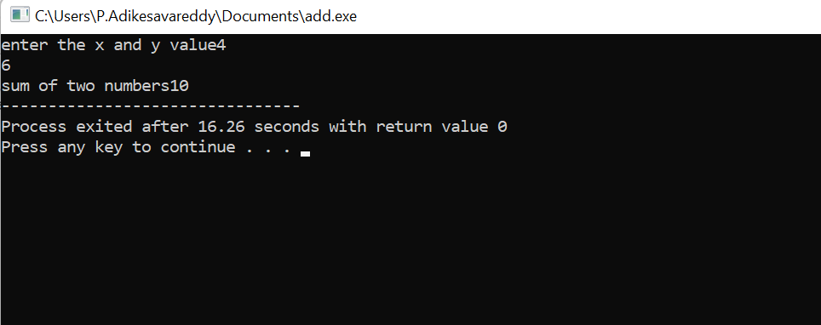

29/08/2022

2.FINDING AGE ELIBLE OR NOT

CODE

#include <iostream>

using namespace std;

int main()

{

int age;

cout<<"age";

cin>>age;

if(age>=18)

cout<<"eligible";

else

cout<<"not eligible";

}

OUTPUT:

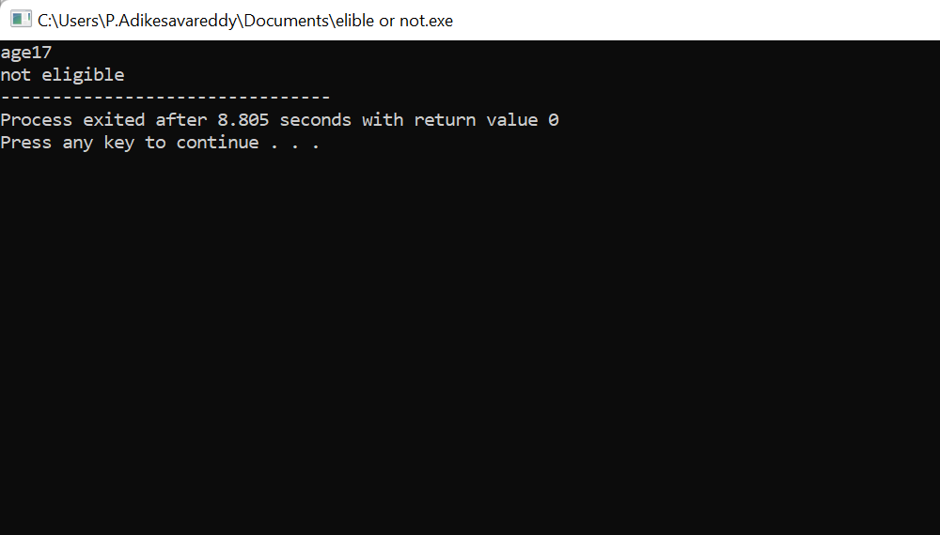

3.EVEN AND ODD NUMBER

#include <iostream>

using namespace std;

int main()

{

int n;

cout<<"enter number";

cin>>n;

if("n%2==0")

cout<<"number is even";

else

cout<<"number is odd";

}

OUTPUT:

enter number4

number is even

4.AREA AND CIRCUMFERENCE OF THE CIRCLE

CODE

#include<iostream>

using namespace std;

main()

{

float r;

cout<<"enter the r value";

cin>>r;

int exp;

cout<<"enter the choice";

cin>>exp;

switch(exp)

{

case 1:

cout<<"area of the circle"<<3.14\*r\*r;

break;

{

case 2:

cout<<"circumference of circle"<<2\*3.14\*r;

break;

}

}

}

OUTPUT:

enter the r value24

enter the choice2

circumference of circle150.72